DSSDL1 X set 1 baseline mode

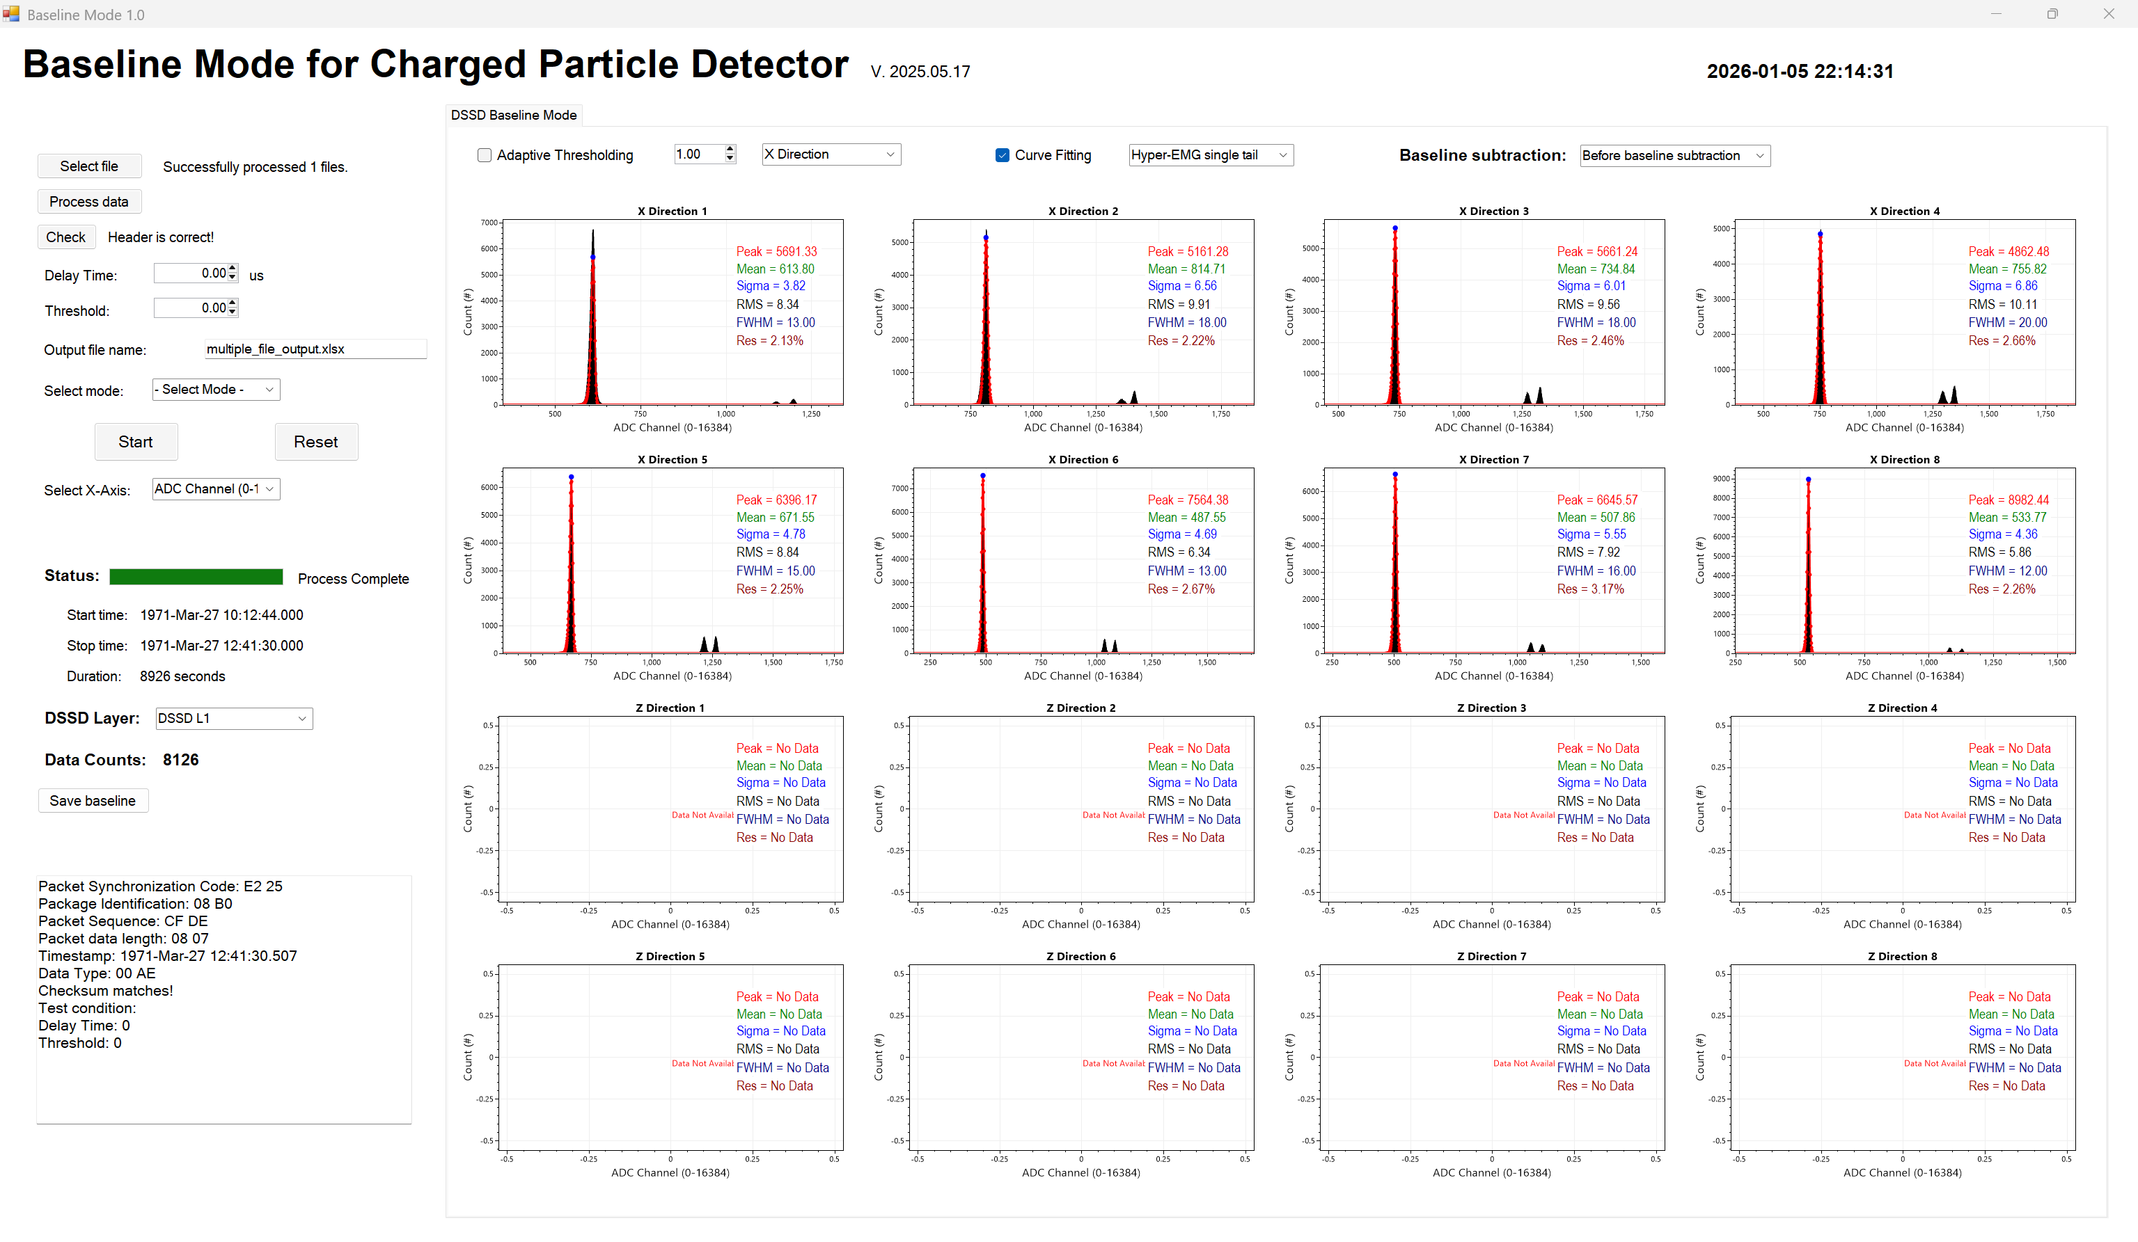

DSSDL1 X set 2 baseline mode

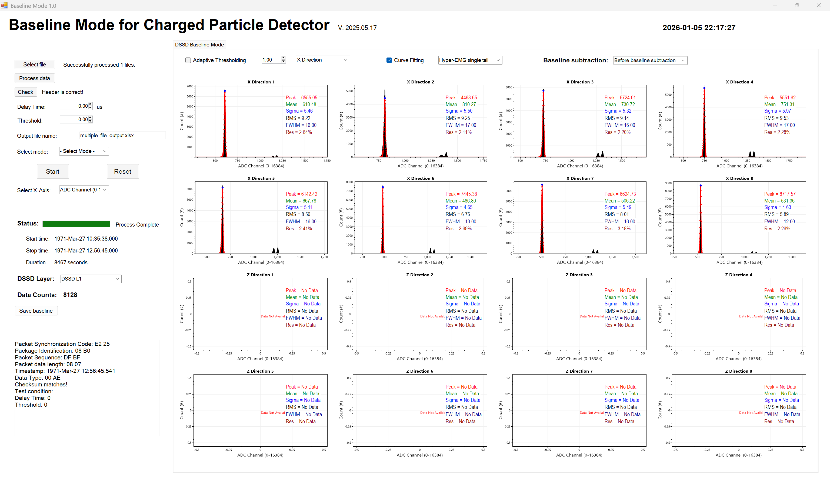

DSSDL1 X set 3 baseline mode

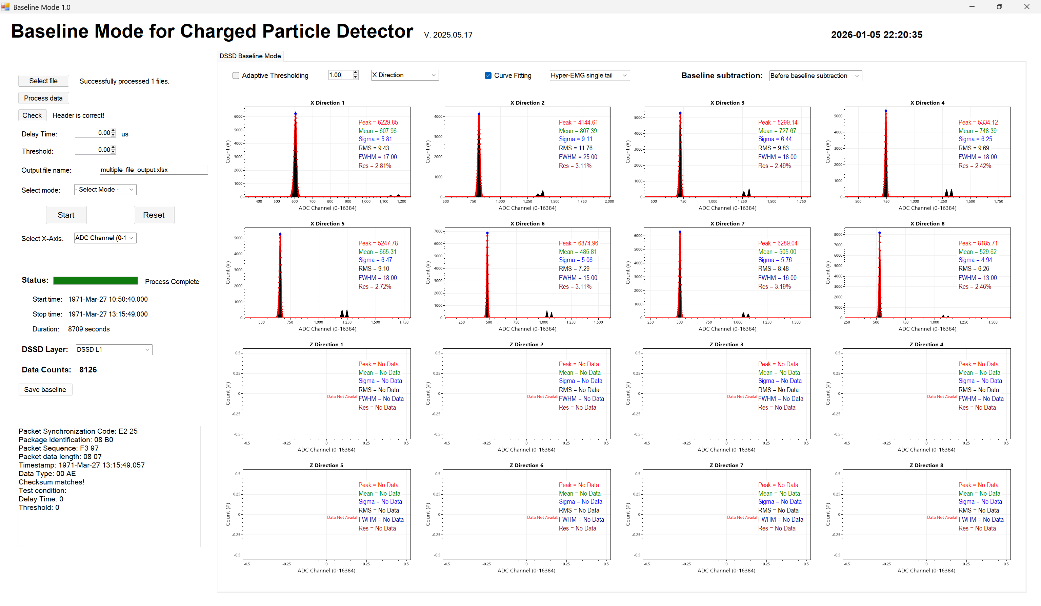

DSSDL1 Z set 1 baseline mode

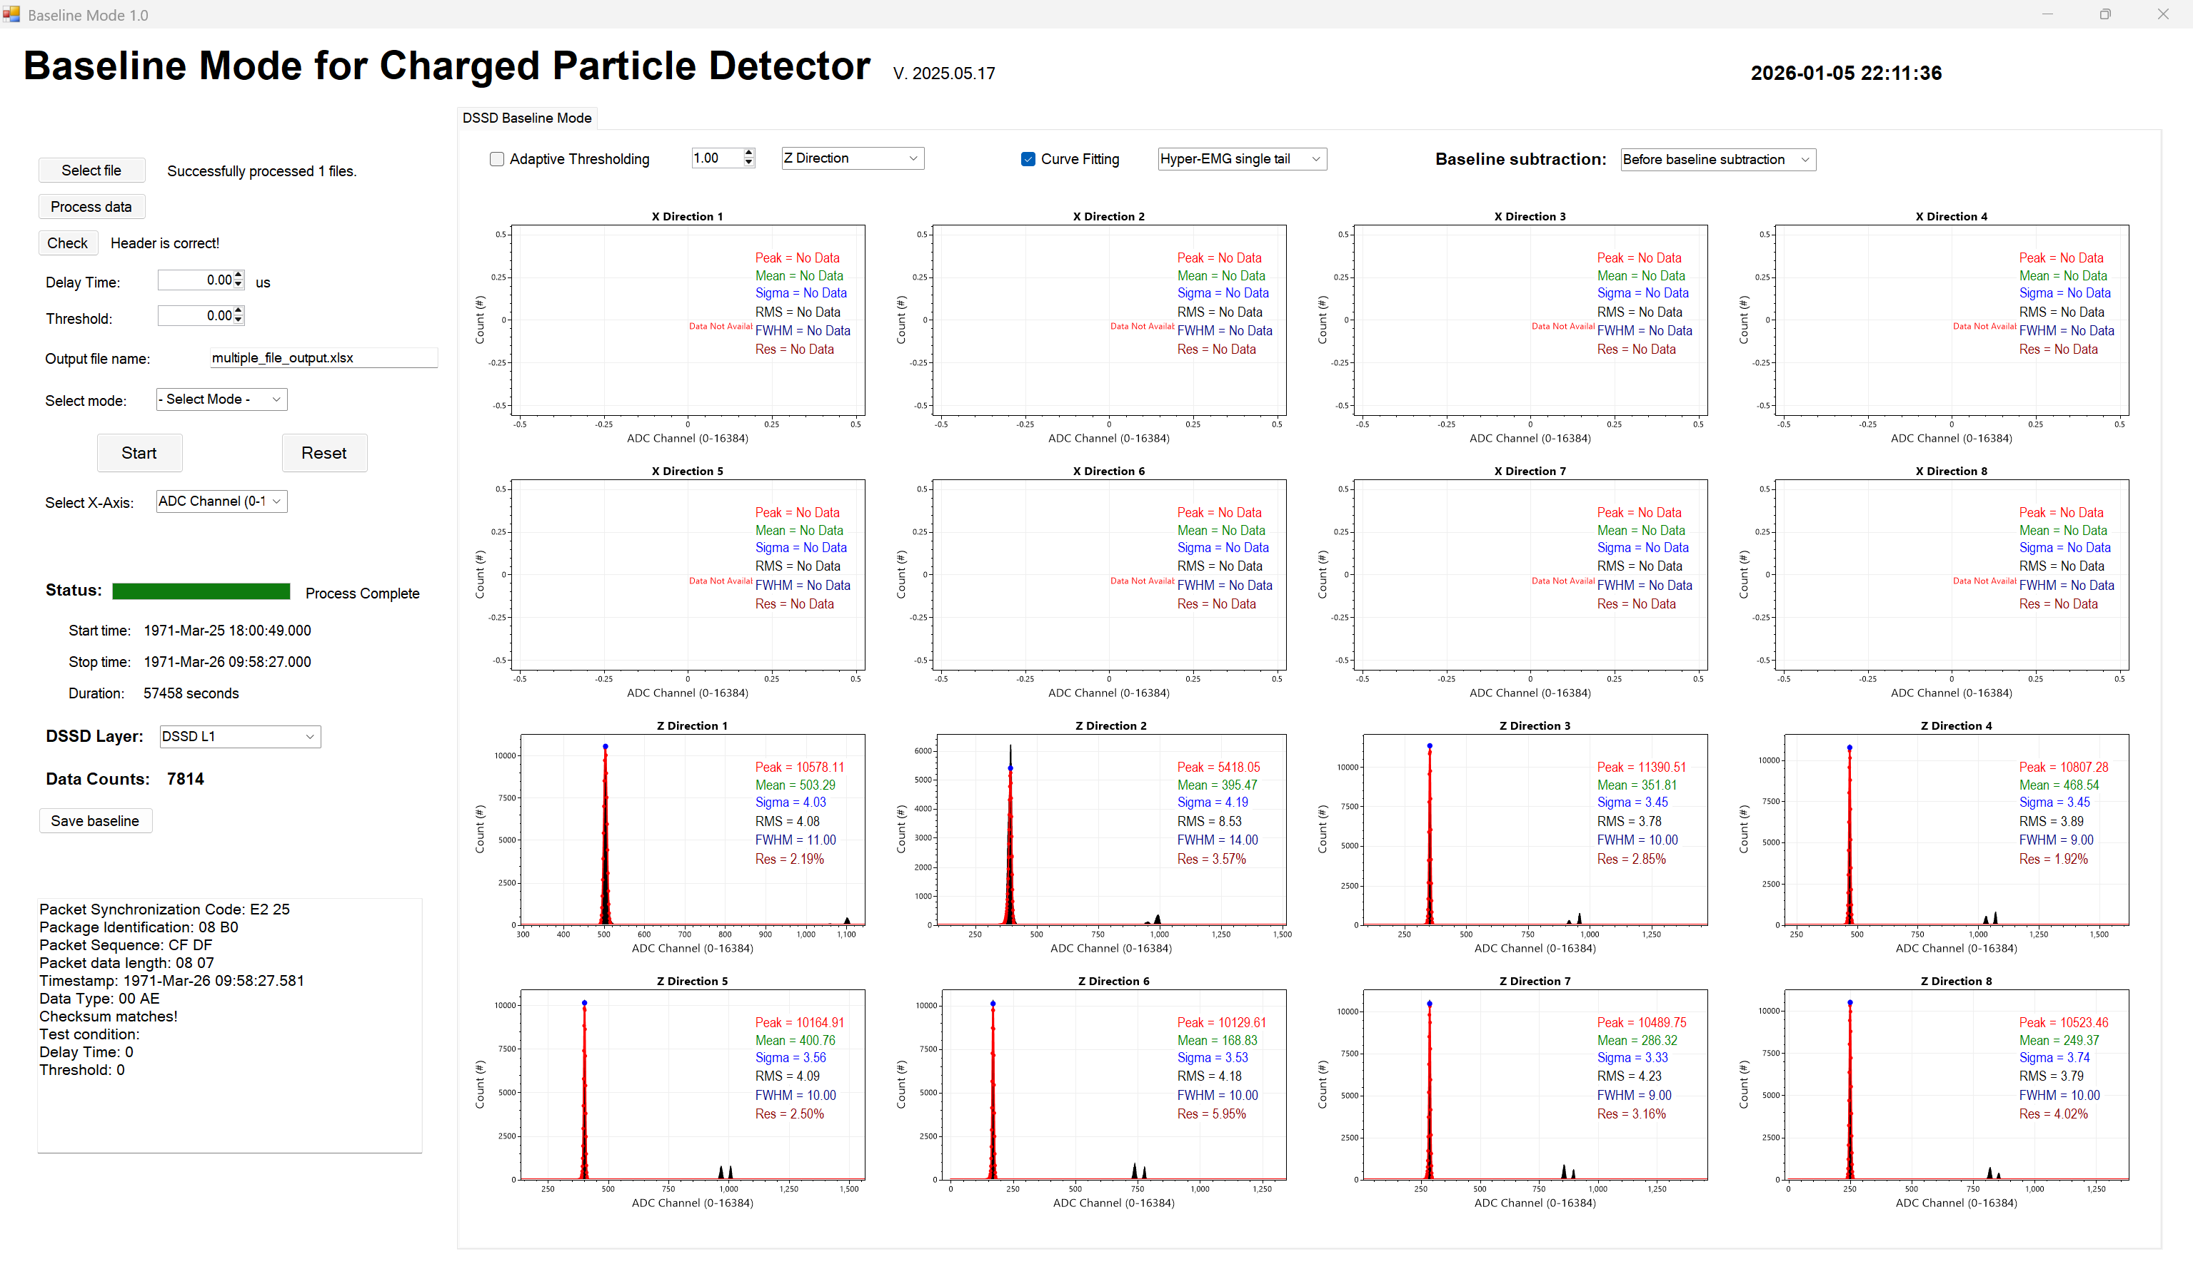

DSSDL1 Z set 2 baseline mode

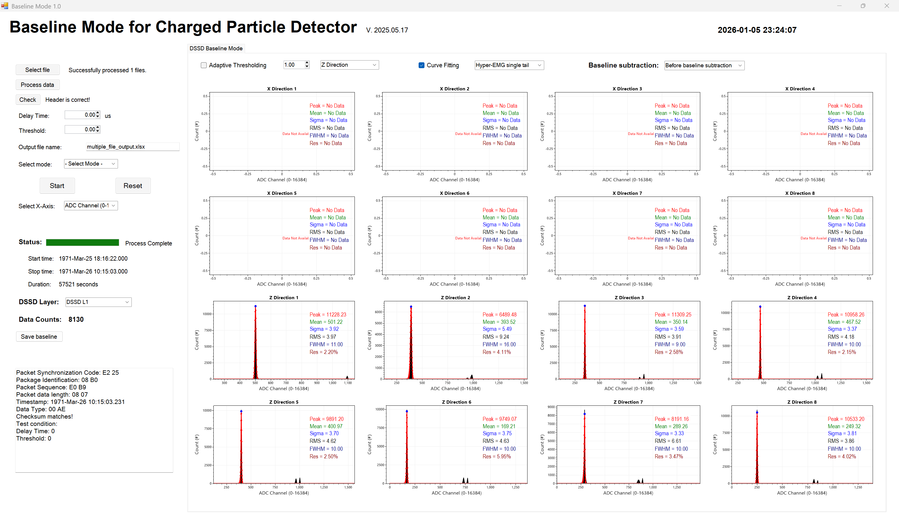

DSSDL1 Z set 3 baseline mode

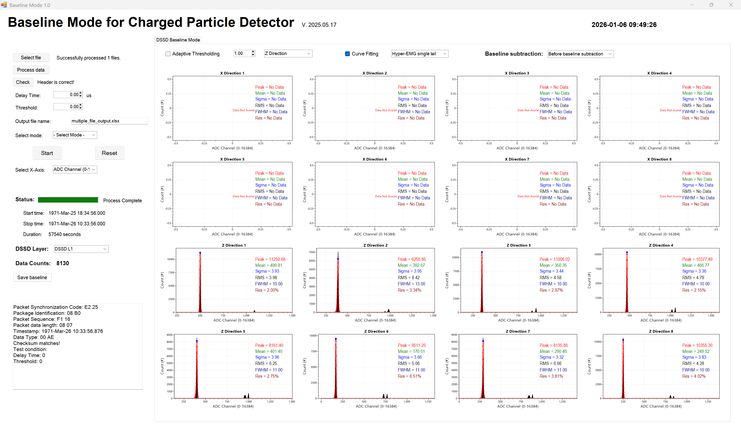

DSSDL2 X set 1 baseline mode

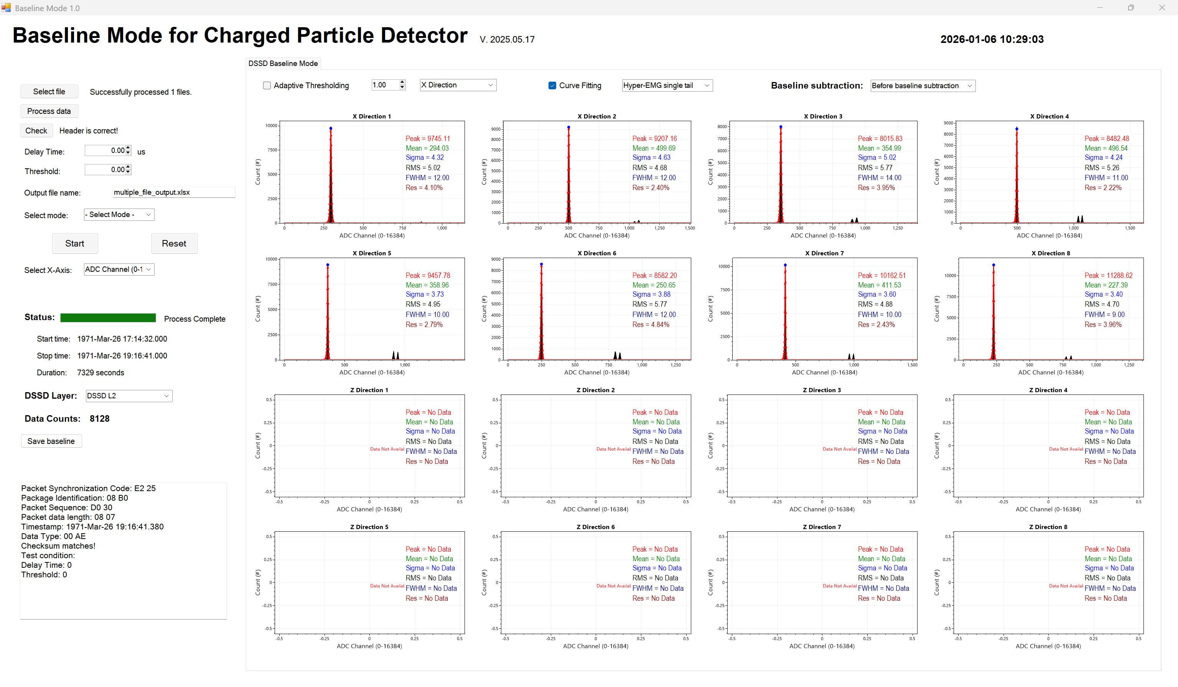

DSSDL2 X set 2 baseline mode

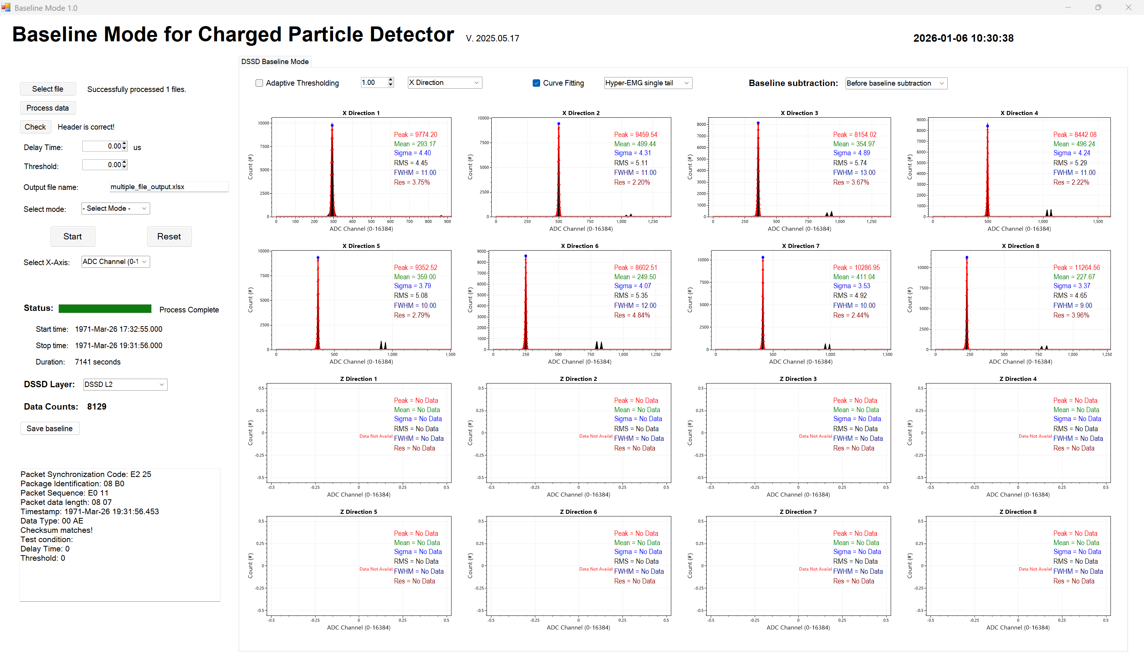

DSSDL2 X set 3 baseline mode

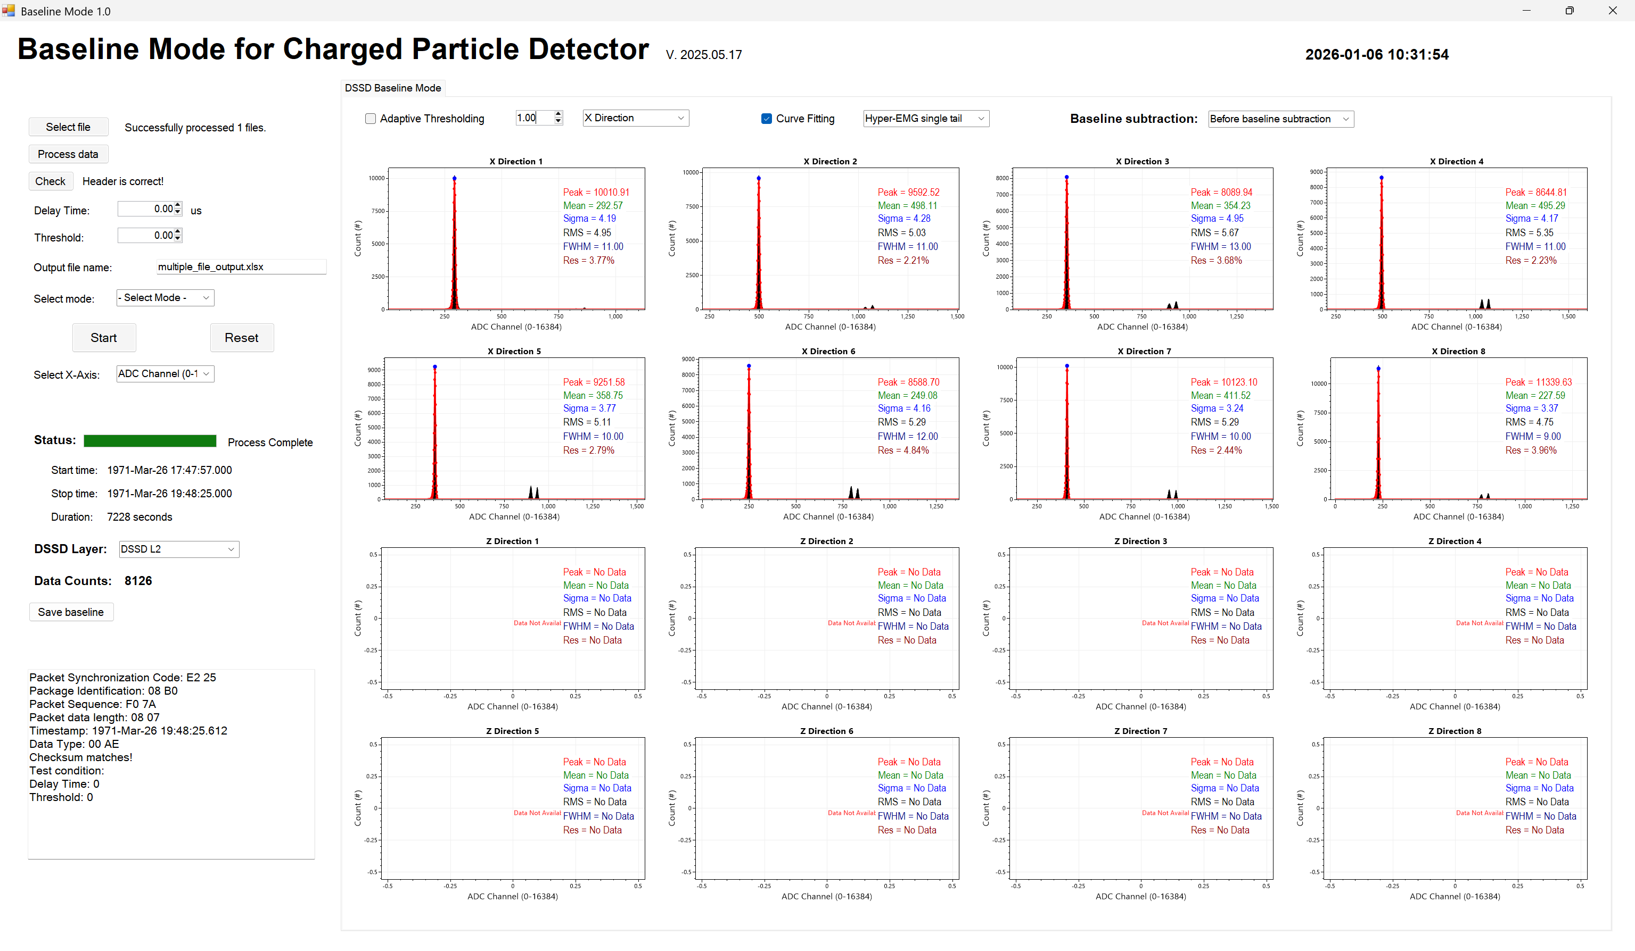

DSSDL2 Z set 1 baseline mode

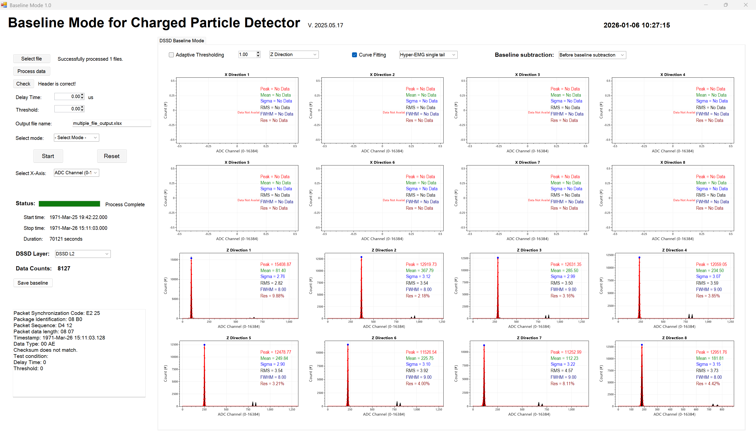

DSSDL2 Z set 2 baseline mode

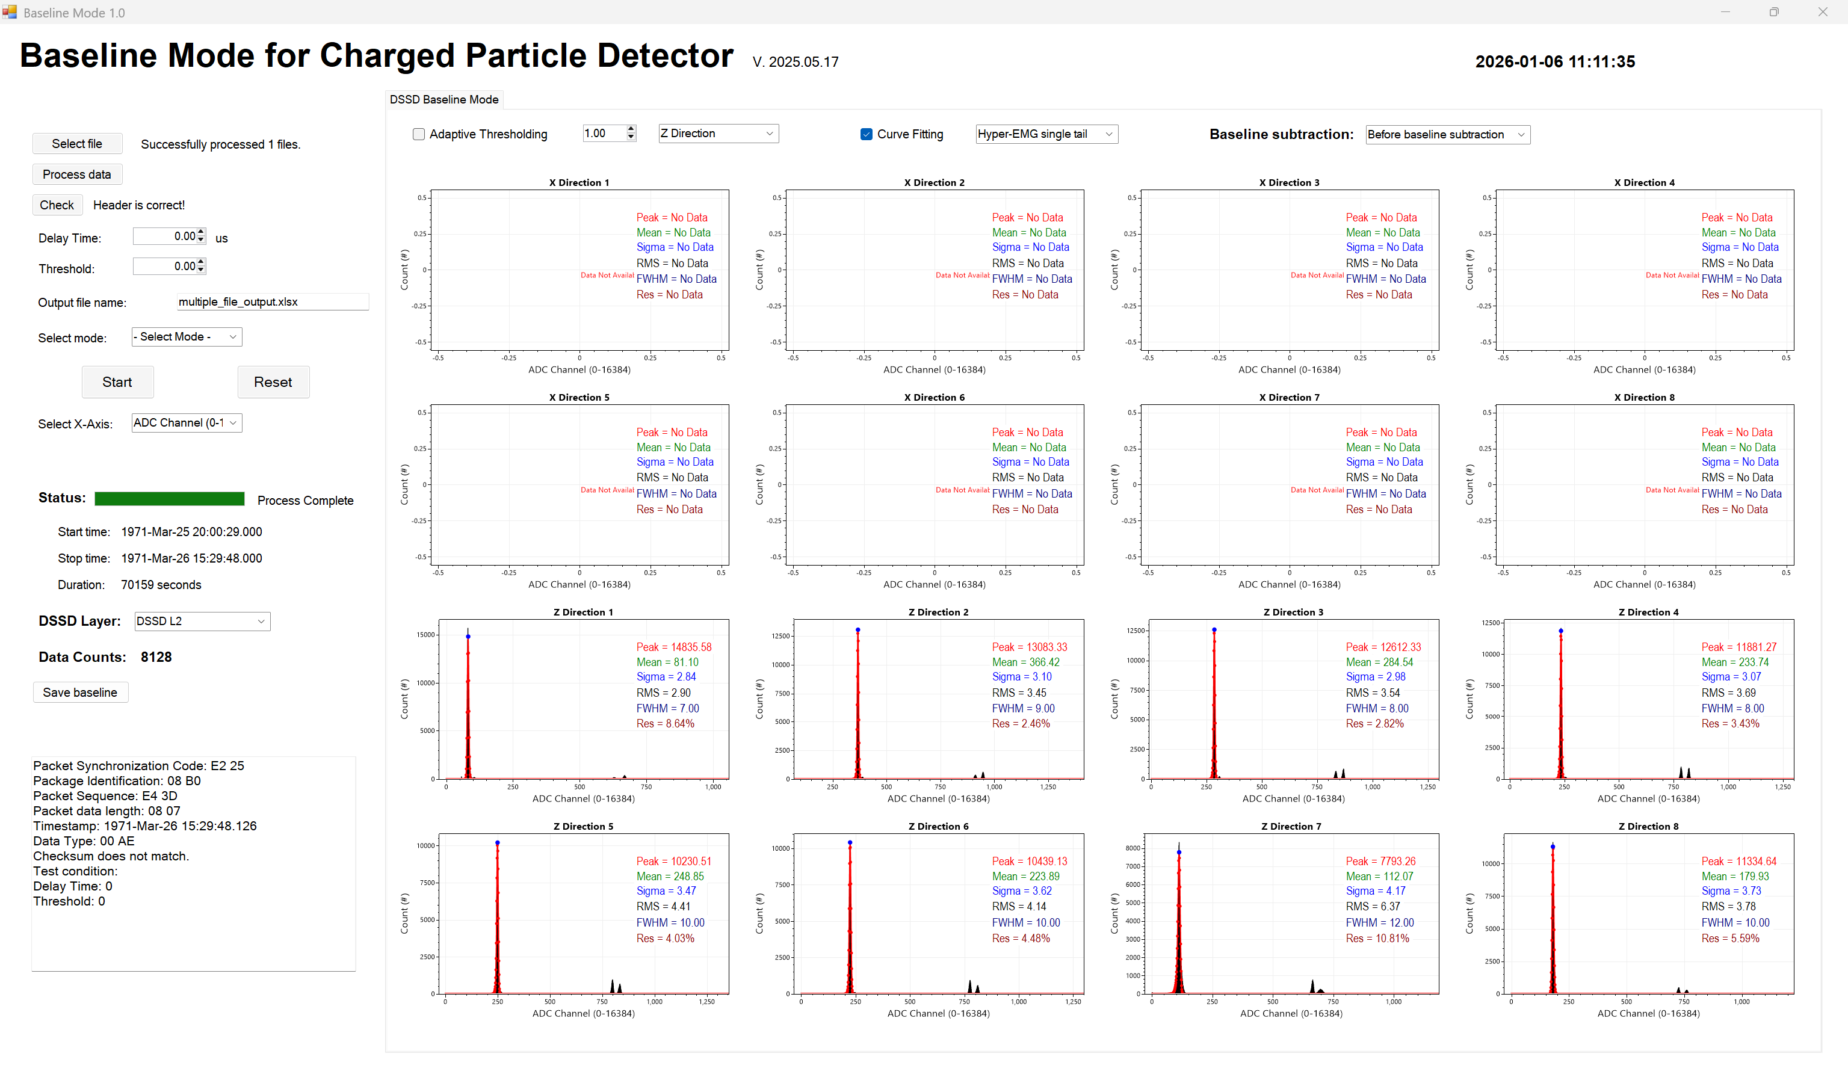

DSSDL2 Z set 3 baseline mode

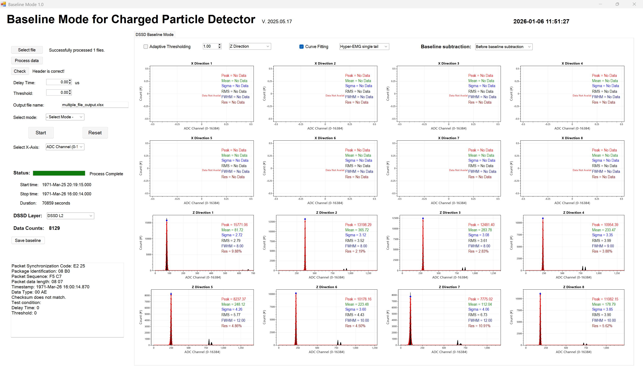

DSSDL6 X set 1 baseline mode

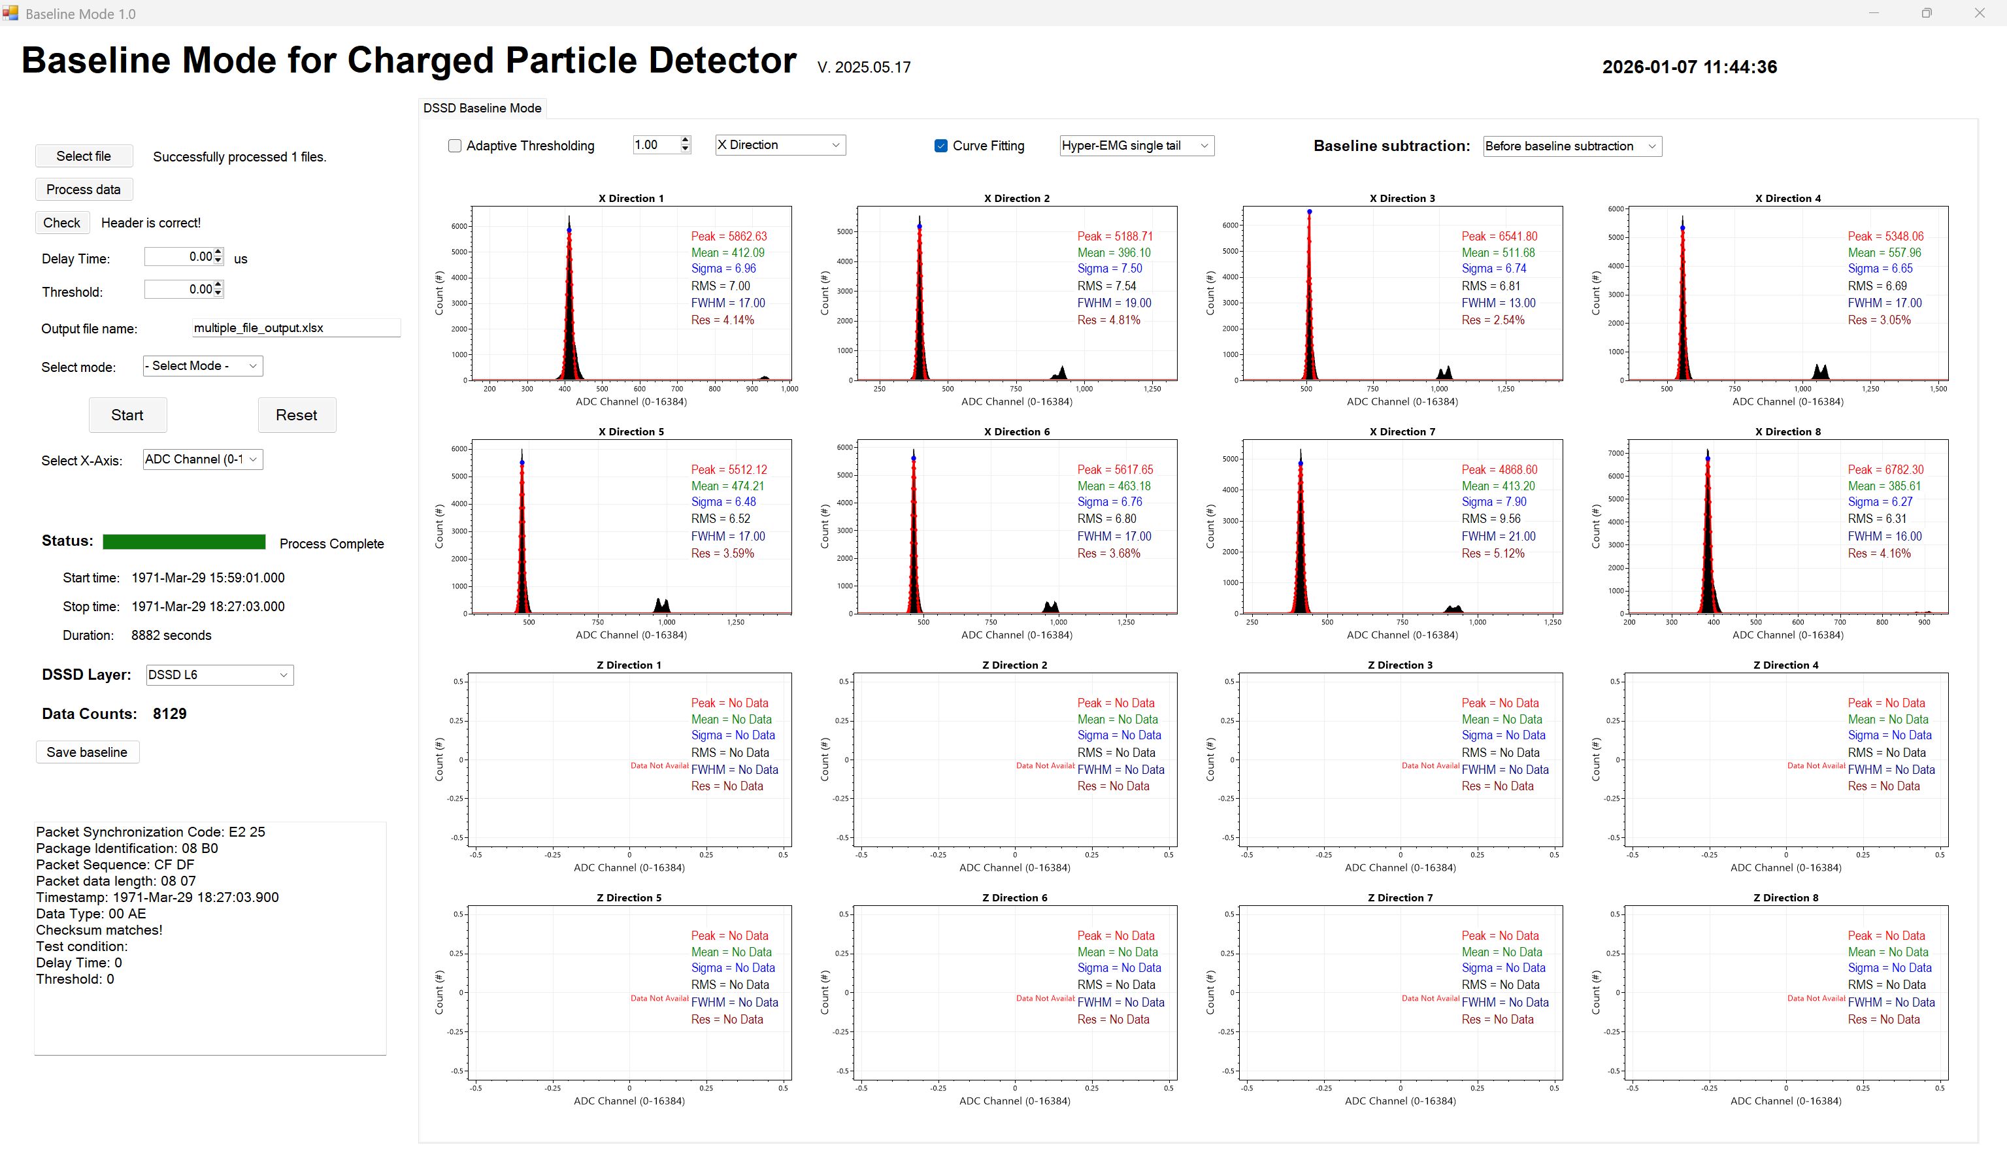

DSSDL6 X set 2 baseline mode

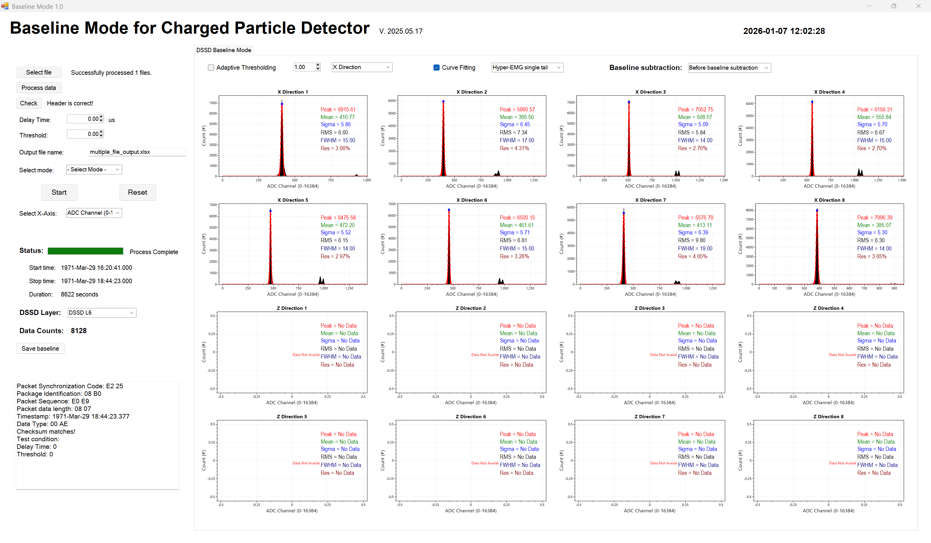

DSSDL6 X set 3 baseline mode

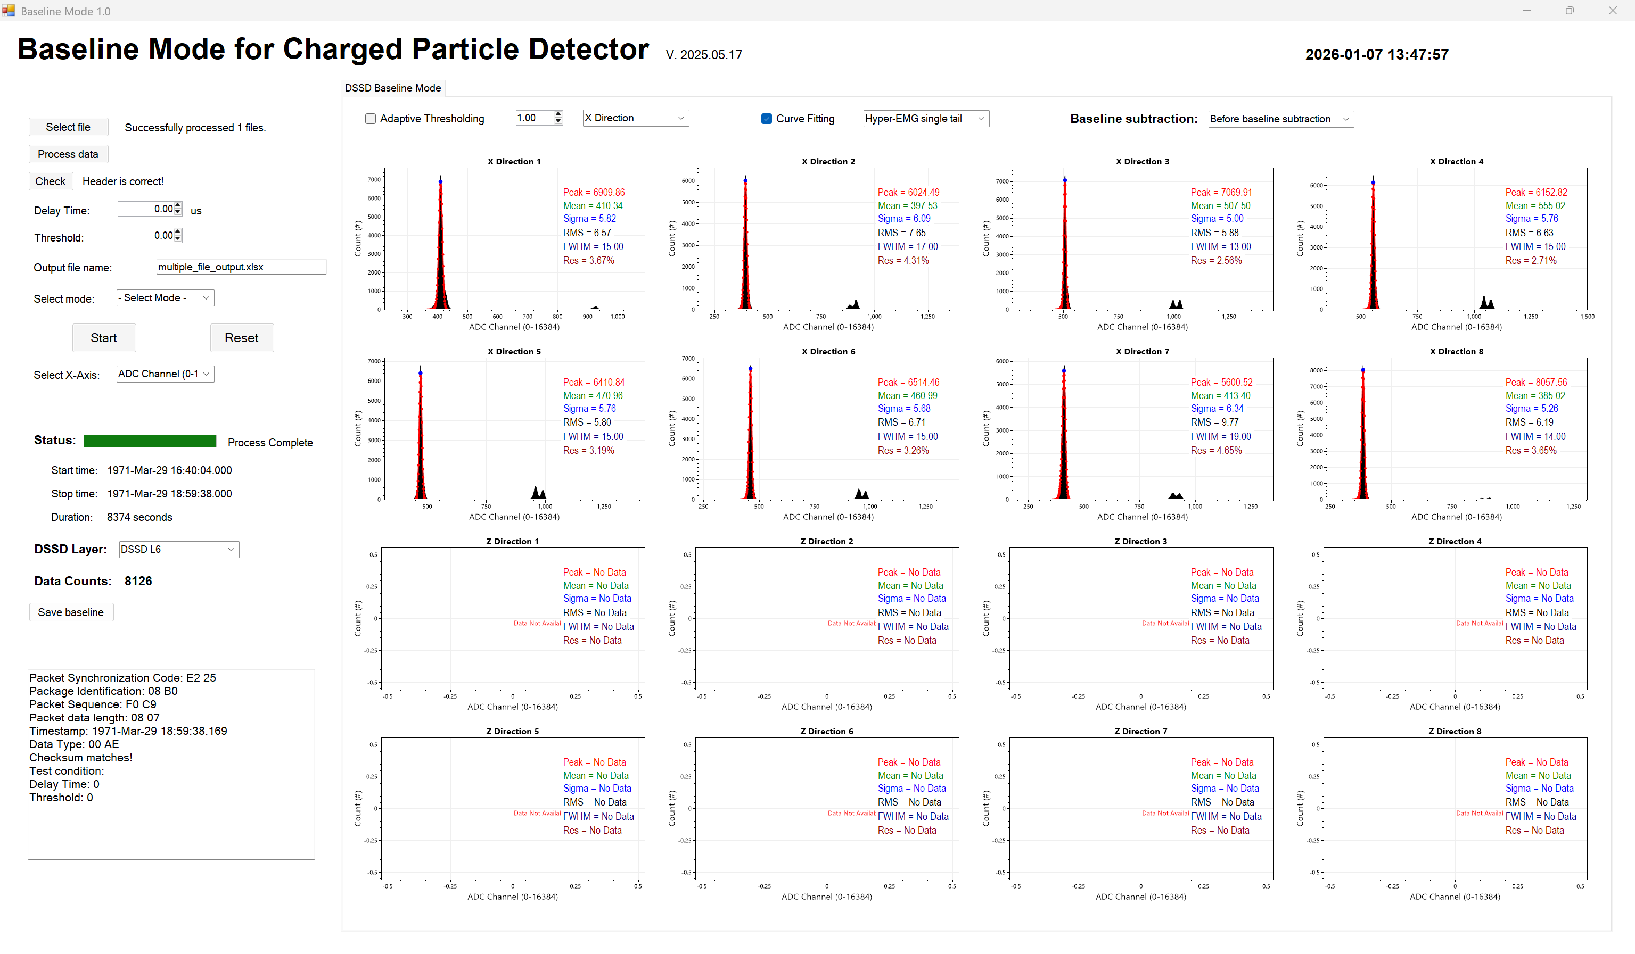

DSSDL6 Z set 1 baseline mode

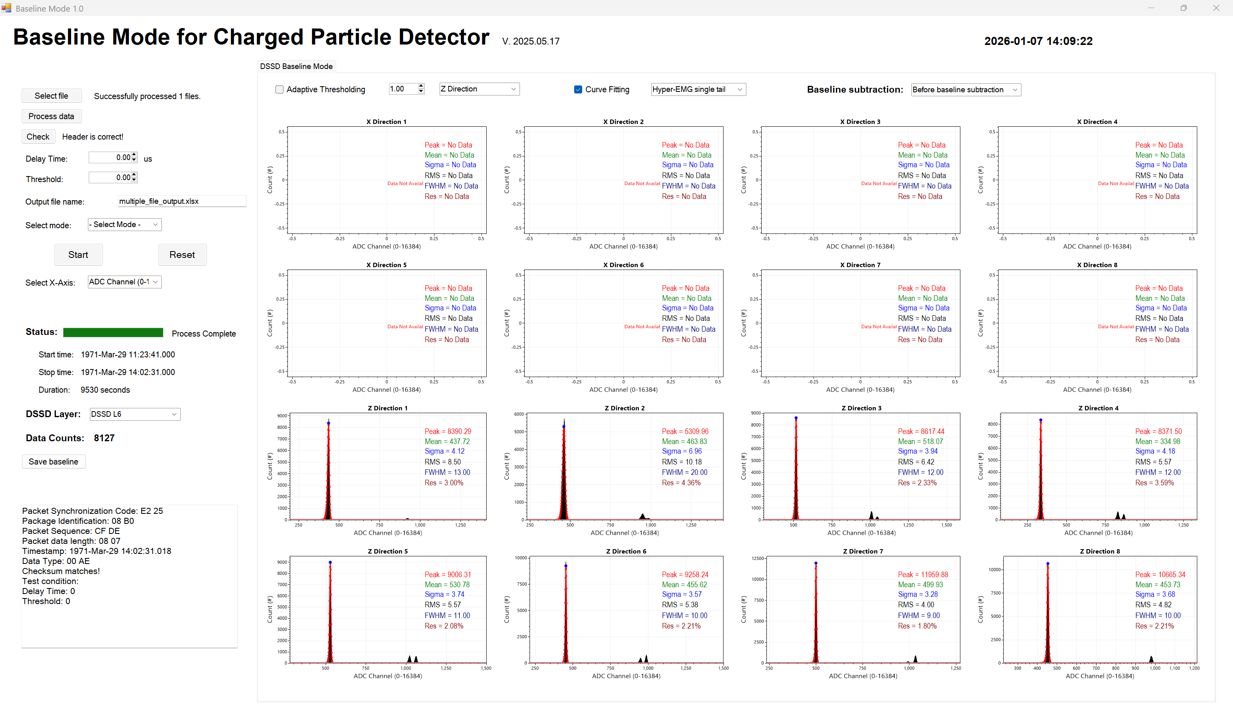

DSSDL6 Z set 2 baseline mode

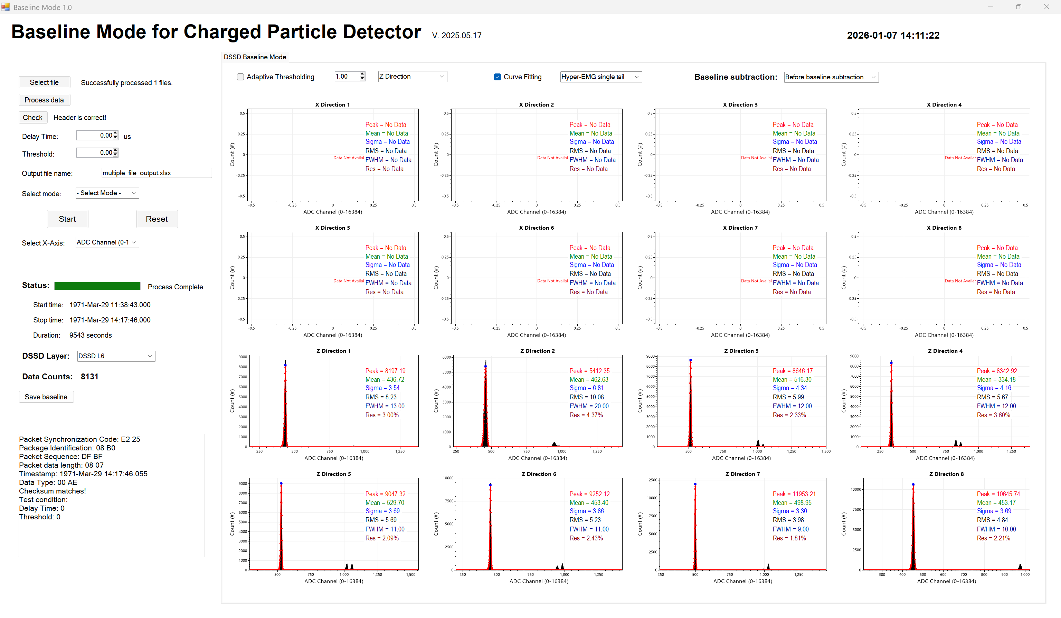

DSSDL6 Z set 3 baseline mode

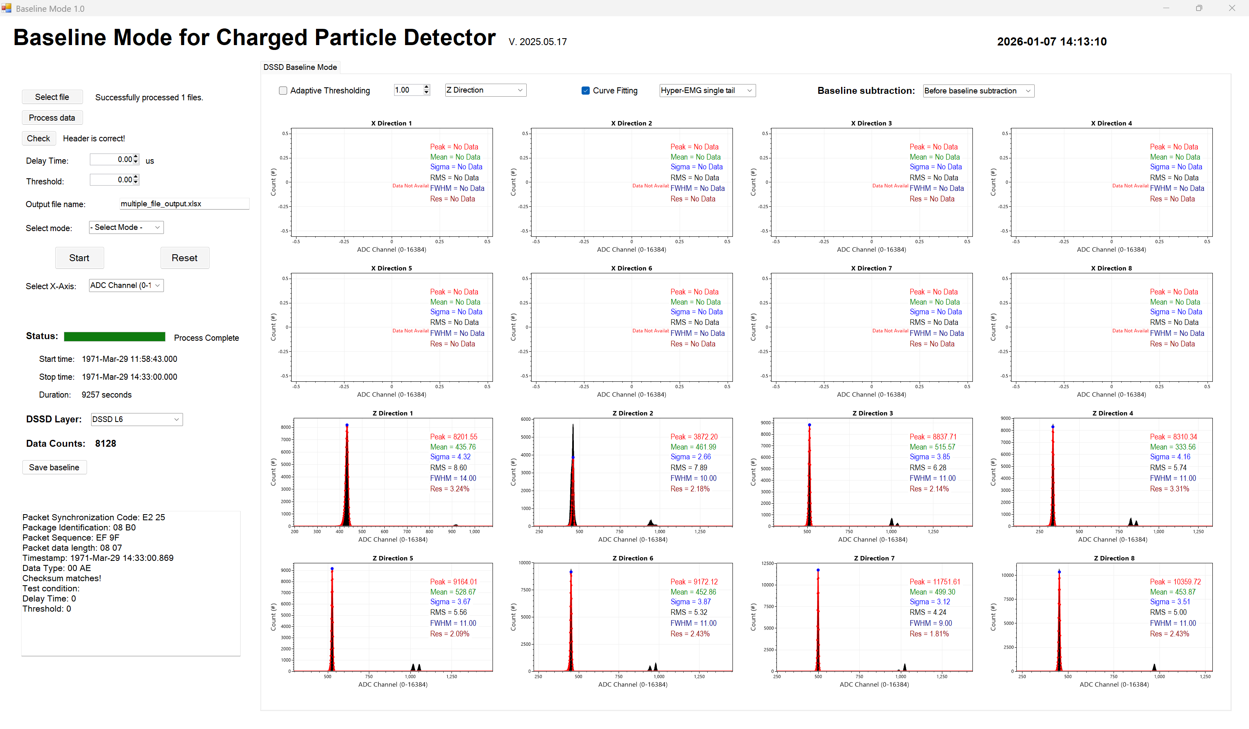

DSSDL7 X set 1 baseline mode

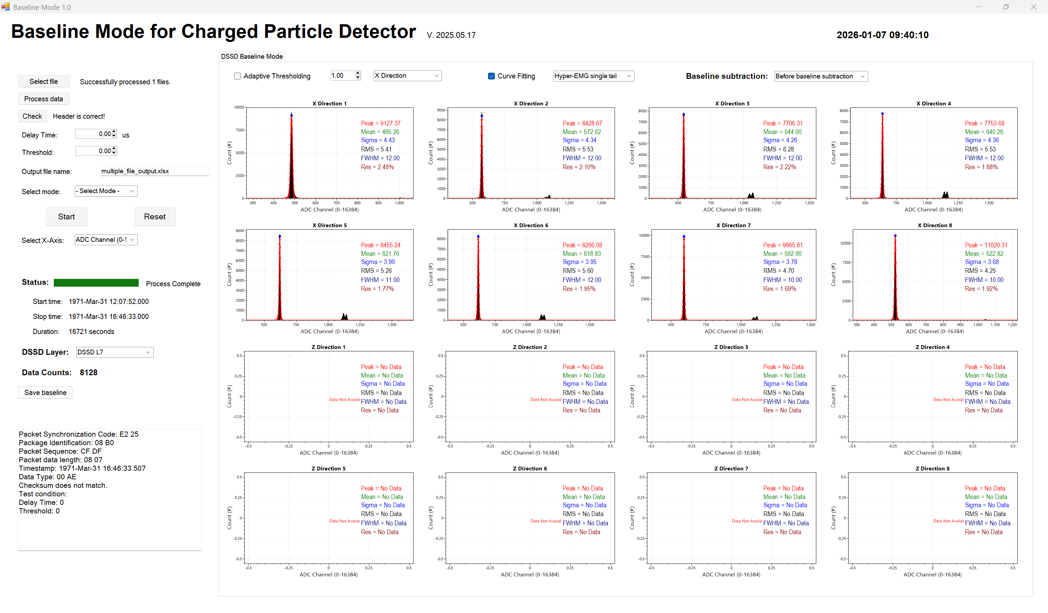

DSSDL7 X set 2 baseline mode

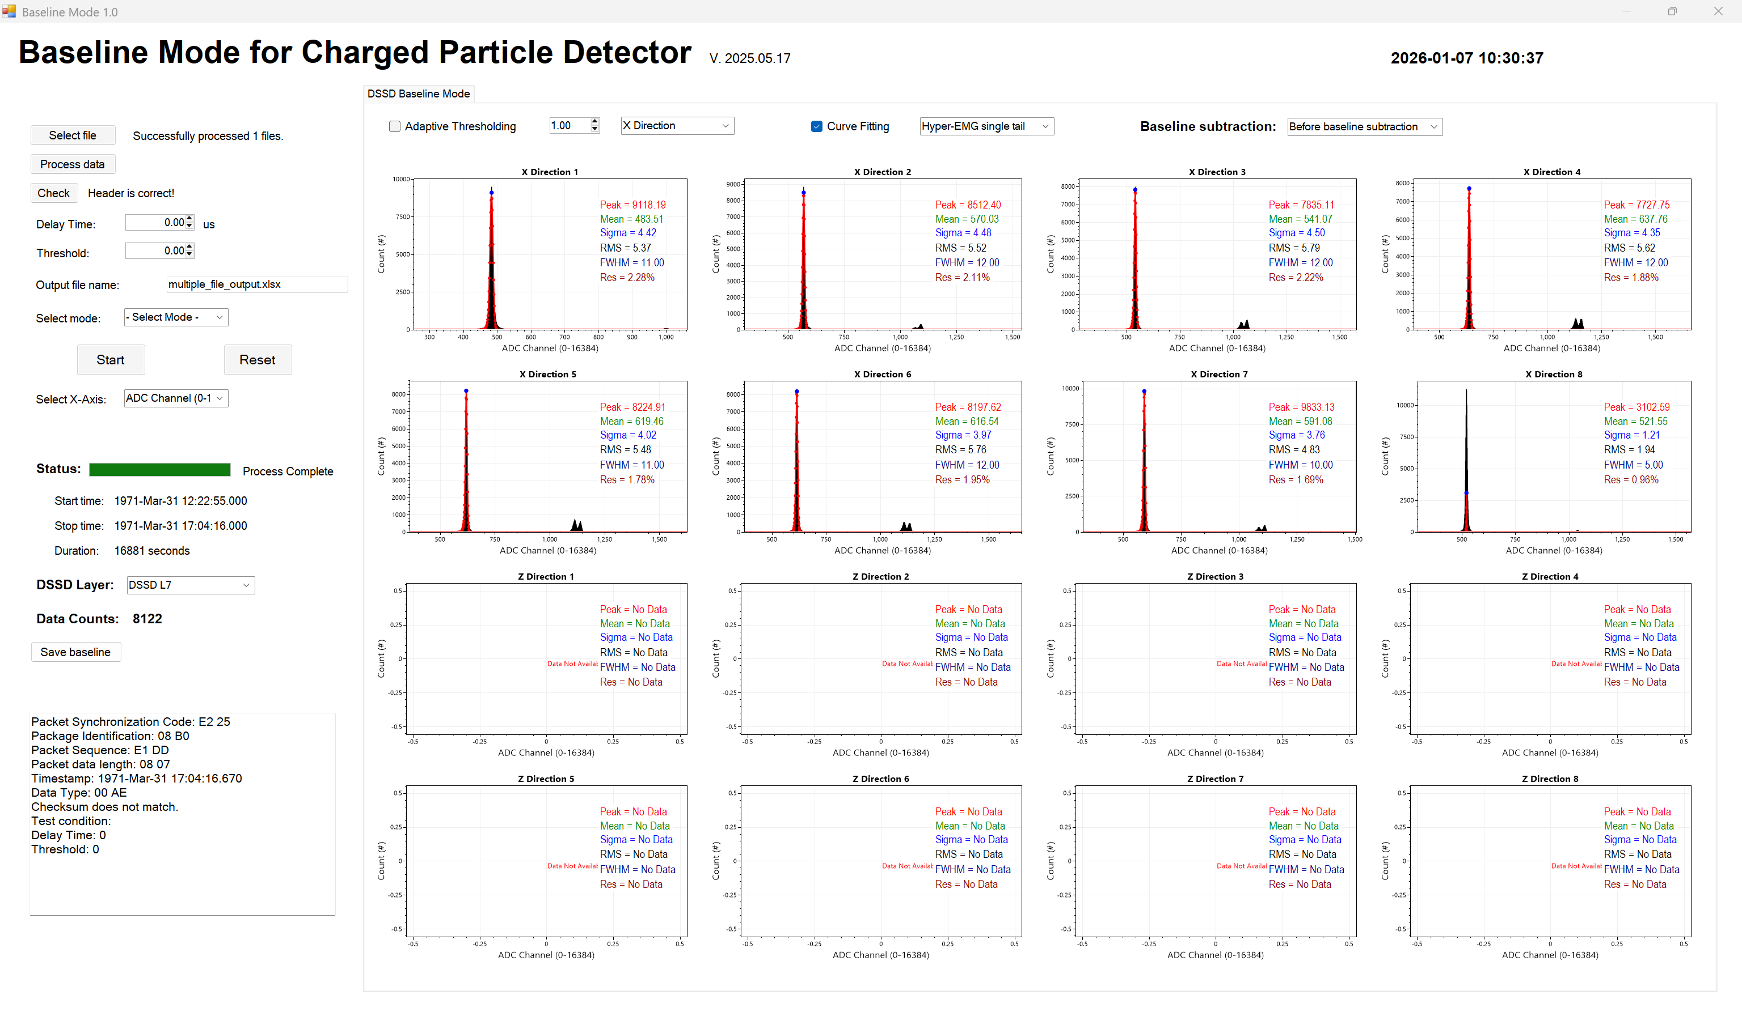

DSSDL7 X set 3 baseline mode

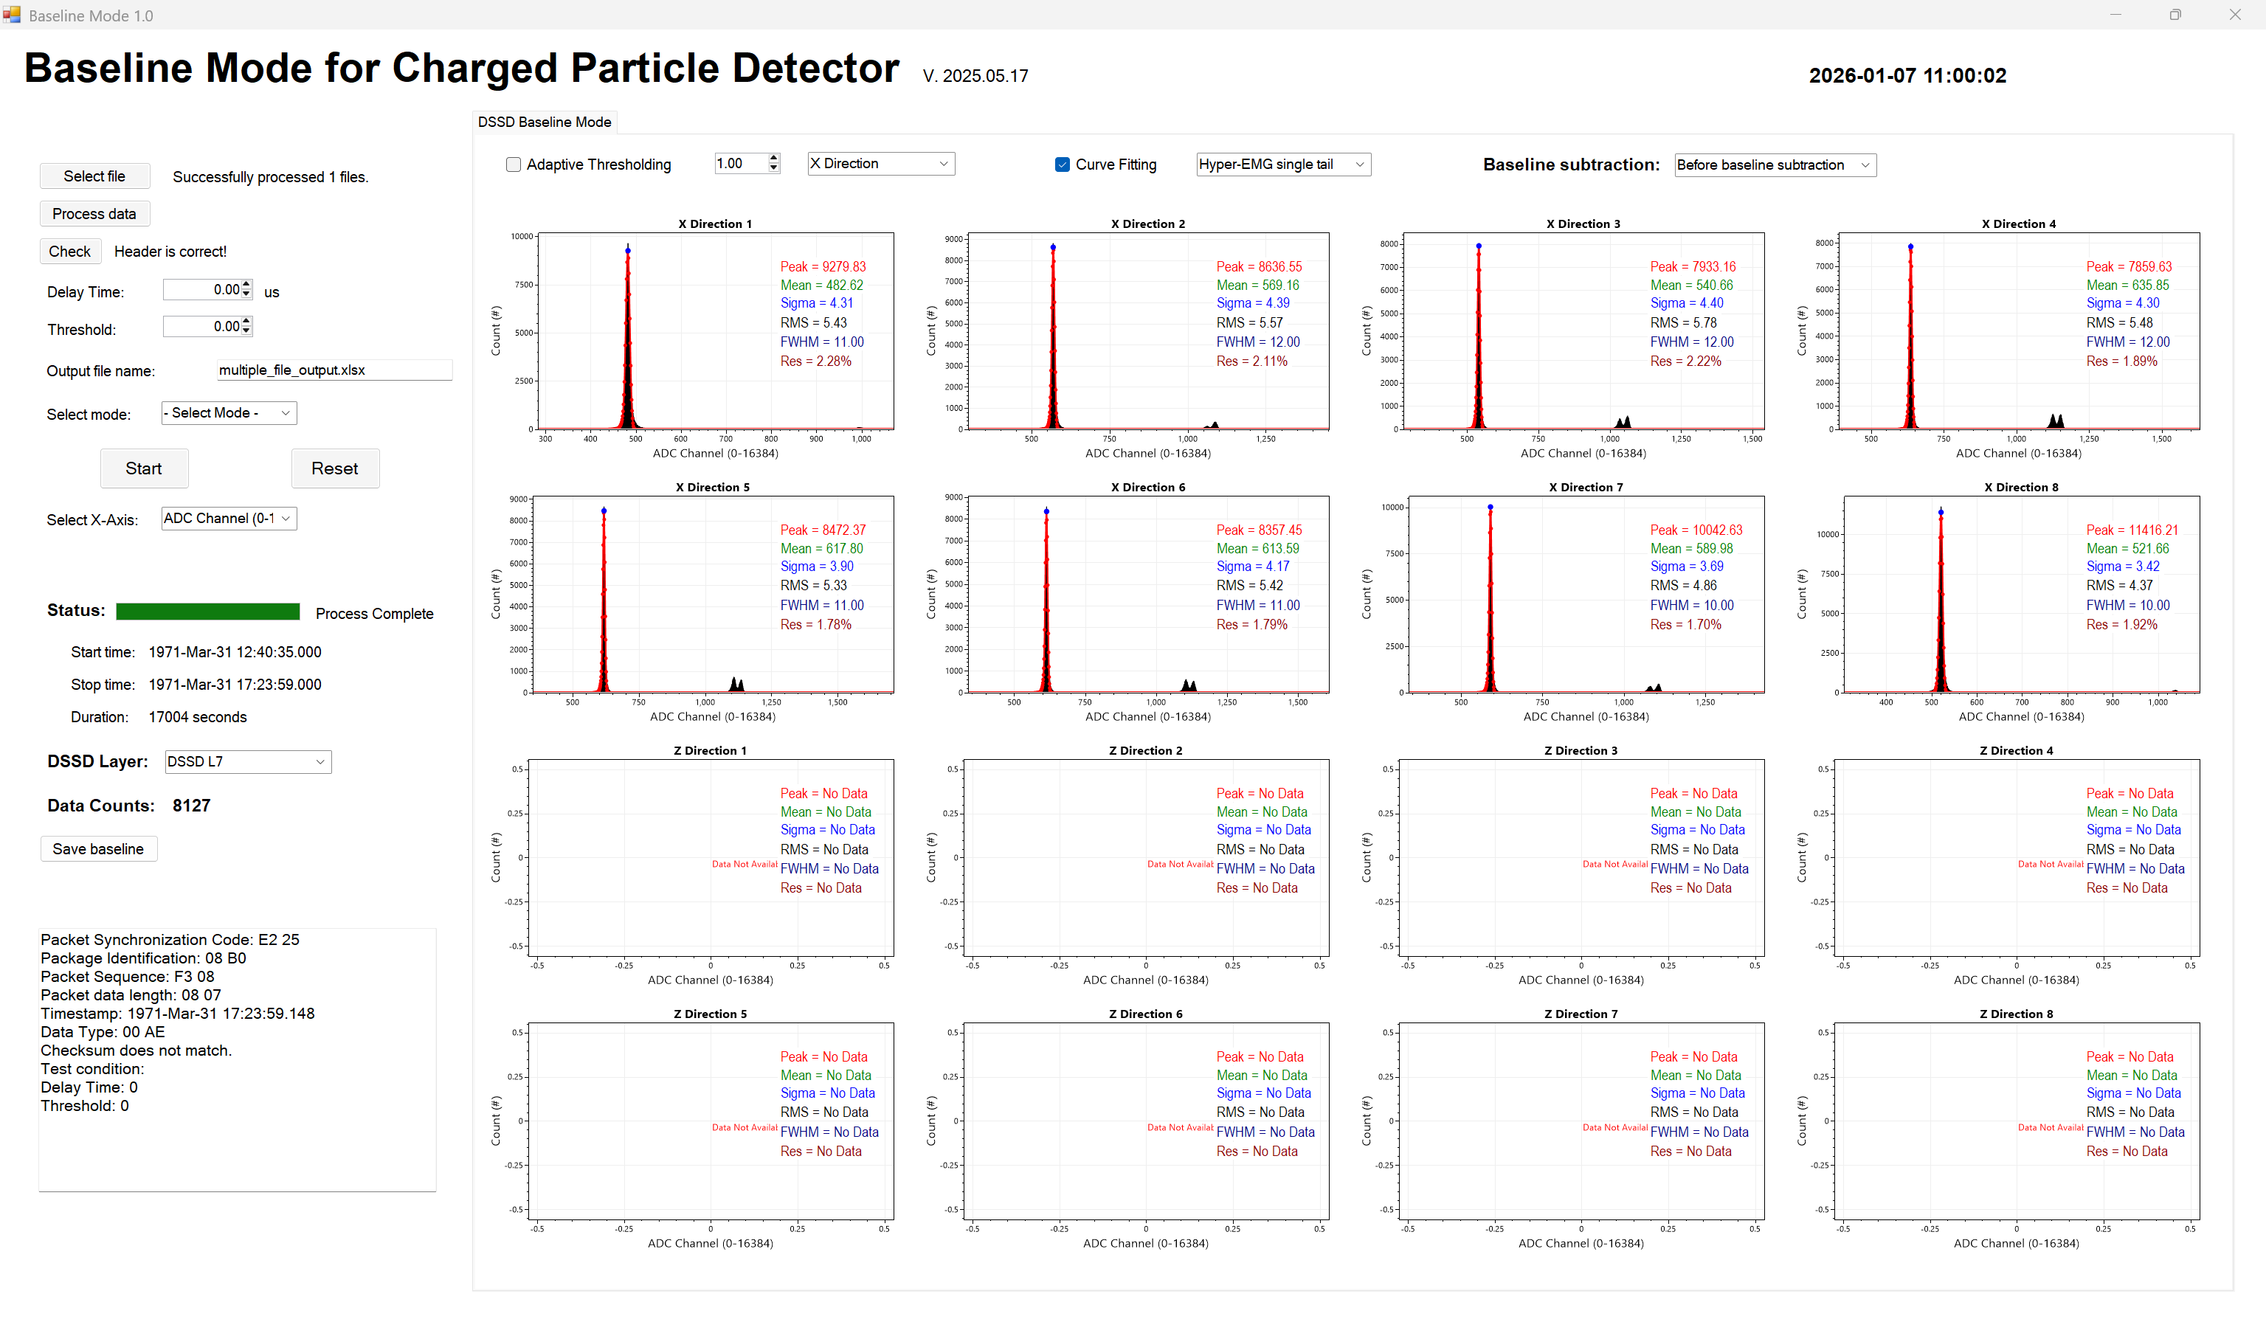

DSSDL7 Z set 1 baseline mode

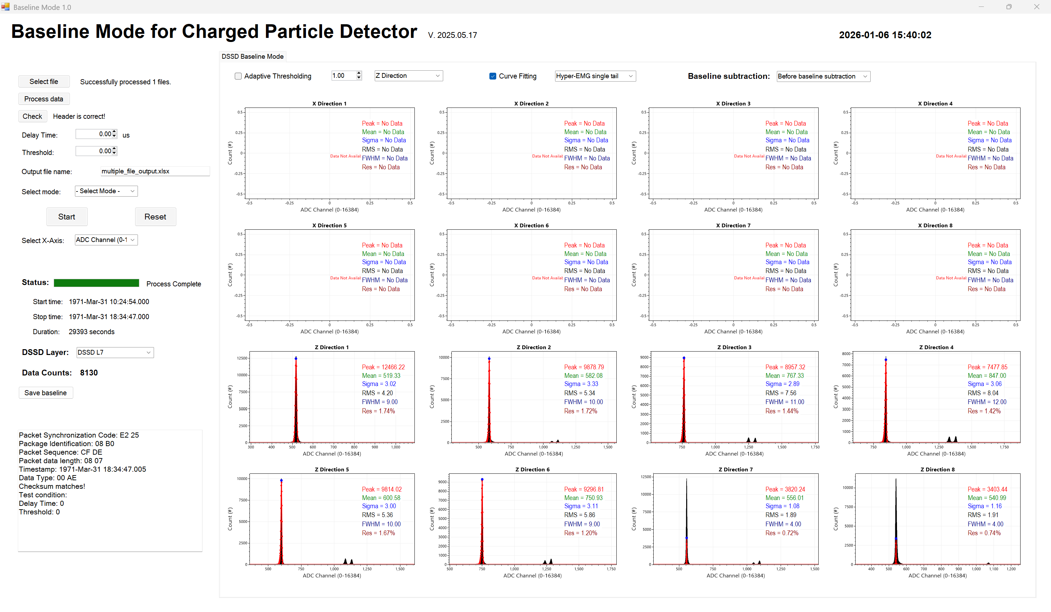

DSSDL7 Z set 2 baseline mode

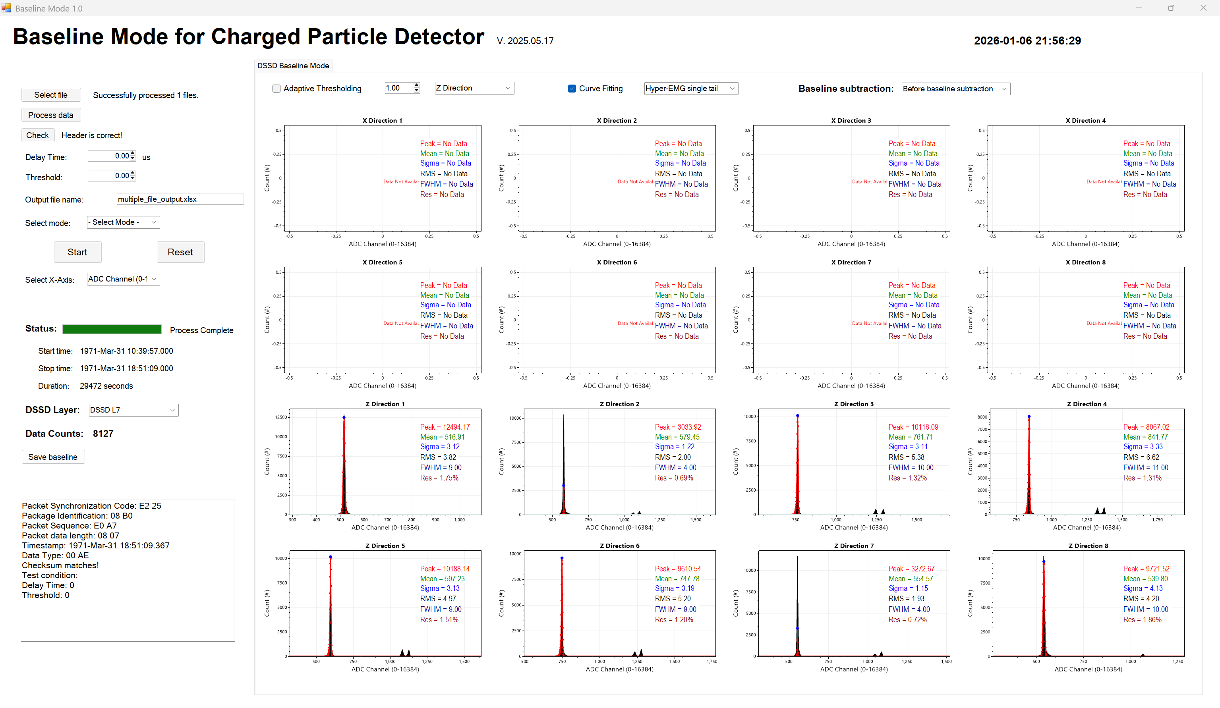

DSSDL7 Z set 3 baseline mode

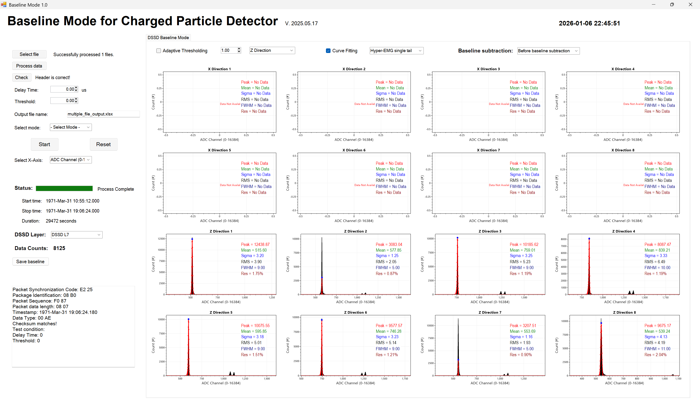

**Baseline Data**

|  |  |  |  |  |  |  |  |  |  |  |  |  |
| --- | --- | --- | --- | --- | --- | --- | --- | --- | --- | --- | --- | --- |
| **Strip** | **DSSDL1** | | | **DSSDL2** | | | **DSSDL6** | | | **DSSDL7** | | |
| **set 1** | **set 2** | **set 3** | **set 1** | **set 2** | **set 3** | **set 1** | **set 2** | **set 3** | **set 1** | **set 2** | **set 3** |
| X-1 | 613.80 | 610.48 | 607.96 | 294.03 | 293.17 | 292.57 | 412.09 | 410.77 | 410.34 | 485.26 | 483.51 | 482.62 |
| X-2 | 814.71 | 810.27 | 807.39 | 499.69 | 499.44 | 498.11 | 396.10 | 395.50 | 397.53 | 572.62 | 570.03 | 569.16 |
| X-3 | 734.84 | 730.72 | 727.67 | 354.99 | 354.97 | 354.23 | 511.68 | 508.07 | 507.50 | 544.00 | 541.07 | 540.66 |
| X-4 | 755.82 | 751.31 | 748.39 | 496.54 | 496.24 | 495.29 | 557.96 | 555.84 | 555.02 | 640.26 | 637.76 | 635.85 |
| X-5 | 671.55 | 667.78 | 665.31 | 358.96 | 359.00 | 358.75 | 474.21 | 472.20 | 470.96 | 621.76 | 619.46 | 617.80 |
| X-6 | 487.55 | 486.80 | 485.81 | 250.65 | 249.50 | 249.08 | 463.18 | 461.61 | 460.99 | 618.83 | 616.54 | 613.59 |
| X-7 | 507.86 | 506.22 | 505.00 | 411.53 | 411.04 | 411.52 | 413.20 | 413.11 | 413.40 | 592.90 | 591.08 | 589.98 |
| X-8 | 533.77 | 531.36 | 529.62 | 227.39 | 227.67 | 227.59 | 385.61 | 385.07 | 385.02 | 522.82 | 521.55 | 521.66 |
| Z-1 | 503.29 | 501.22 | 499.81 | 81.40 | 81.10 | 81.72 | 437.72 | 436.72 | 435.76 | 519.33 | 516.91 | 515.60 |
| Z-2 | 395.47 | 393.52 | 392.67 | 367.79 | 366.42 | 365.72 | 463.83 | 462.63 | 461.99 | 582.08 | 579.45 | 577.85 |
| Z-3 | 351.81 | 350.14 | 350.35 | 285.50 | 284.54 | 283.78 | 518.07 | 516.30 | 515.57 | 767.33 | 761.71 | 759.01 |
| Z-4 | 468.54 | 467.52 | 466.77 | 234.50 | 233.74 | 233.47 | 334.98 | 334.18 | 333.56 | 847.00 | 841.77 | 839.21 |
| Z-5 | 400.76 | 400.97 | 401.40 | 249.84 | 248.85 | 248.12 | 530.78 | 529.70 | 528.67 | 600.58 | 597.23 | 595.85 |
| Z-6 | 168.83 | 169.21 | 170.01 | 225.75 | 223.89 | 223.84 | 455.62 | 453.40 | 452.86 | 750.93 | 747.78 | 746.28 |
| Z-7 | 286.32 | 289.26 | 290.46 | 112.23 | 112.07 | 112.04 | 499.93 | 498.95 | 499.30 | 556.01 | 554.57 | 553.69 |
| Z-8 | 249.37 | 249.32 | 249.52 | 181.81 | 179.93 | 178.79 | 453.73 | 453.17 | 453.87 | 540.99 | 539.80 | 539.24 |